The Ten Plagues on Egypt
Are not Random; They Follow a Pattern
First Some Questions
If you are searching for “the ten plagues of Egypt,” “ten plagues and Egyptian gods,” “plagues of Egypt Bible Study,” or “what do the ten plagues of Egypt mean?” this article goes deep into all of it. People also search for “who is Pharaoh in the Bible?” “Why did God harden Pharaoh's heart?” “What is the Passover in the Bible?” “What is the meaning of the Passover lamb?” “What is the meaning of blood on the doorposts?” and “What is the mixed multitude in Exodus?” If you have wondered what each plague targeted, who the Egyptian gods are (Hapi, god of the Nile; Heqet, the frog goddess of Egypt; Ra, the sun god in the Bible; Hathor; Apis), what the plague of livestock was, what the three triads of the plagues are, and more, we will also examine other topics, such as: the plagues reversing Genesis creation, Colossians 2:15 “principalities and powers,” typology in the Old Testament, and how the Old Testament foreshadows Jesus.

Introduction
KEY VERSE: "For I will go through the land of Egypt on that night, and fatally strike all the firstborn in the land of Egypt, from the human firstborn to animals; and against all the gods of Egypt I will execute judgments—I am the Lord. Exodus 12:12 (NASB)
It is crucial to understand that we recognize each plague as a direct attack by God on one or more of the Egyptian gods. Many read the ten plagues of Egypt as a list of ten disasters until Pharaoh gave in. But beneath that list lies a hidden structure — three triads, a deliberate order, and a verdict delivered against the entire Egyptian pantheon, one god at a time. This is the pattern Pharaoh missed, and it is the same pattern people still miss today. Exodus 12.12 unlocks everything. God says He will execute judgment against all the gods of Egypt. Not disasters. Judgment. That is courtroom language. When you read the plagues through that lens, every plague becomes a witness — blood silencing the Nile god Hapi, frogs exposing the fertility goddess Heqet, darkness dethroning Ra himself. Each blow is a charge. Each triad teaches a different truth. And the whole sequence reverses Genesis 1, un-creating Egypt as a sermon no one could ignore. But the plagues were not only aimed at Egypt. They had two audiences from the start: a courtroom for Pharaoh and a classroom for Israel, slaves who had forgotten who their God was. People who needed to be reminded that the Nile was not a god, that the sun was not a god, and that the One who heard their groaning under the bricks held all of it. And the tenth plague stands alone — not because it escalates, but because it changes the question entirely. A lamb. A doorpost. Blood applied in faith. And a mixed multitude of Israelites and Egyptians sheltered under the same promise. Egypt was the rehearsal. The Lamb of God is the reality.
An Examination of the Text
Most people read the 10 plagues of Egypt the same way, as a list. The ten ways God made life miserable in Egypt until Pharaoh finally let the people go. Blood, frogs, gnats, and flies, down the line, until the firstborn died. Ten check marks on a long, painful page. But there is something hidden beneath that list that almost nobody notices on a first read. The plagues are in a specific order. And that order is doing something. It is not random. It is not just escalation. It is a pattern. And the pattern reveals what God was actually doing. He was not just meting out punishments to Egypt. He was building a case against them.
There is one verse that unlocks the whole thing, Exodus 12:12. God speaks it just before the final plague. He tells Moses exactly what has been happening during the first nine plagues. He says, "I will pass through the land of Egypt that night, and I will strike all the firstborn in the land of Egypt, both man and beast. And against all the gods of Egypt, I will execute judgment. I am the Lord." Really look at that line again, “Against all the gods of Egypt, I will execute judgment.” That is not the language of disasters; it is the language of a courtroom. The plagues were never primarily about water, frogs, and weather. They were trials—each one a specific charge, each a piece of evidence. The verdict was being delivered against the entire Egyptian pantheon, one defendant at a time. That is a pattern Pharaoh missed, and it is one people still miss today.
To understand what the plagues are doing, you have to understand who Pharaoh thought he was and who his gods were. In ancient Egypt, a Pharaoh was not just a king. He was considered a living god—the son of Ra, the sun god. His title, Pharaoh, meant “great house.” The great house was believed to be the bridge between the divine and human realms. When Pharaoh spoke, the people believed the gods were speaking through him. Therefore, when he ruled, the cosmic order was upheld.
That is why the very first thing Pharaoh says when Moses shows up to deliver God's message is the line in Exodus 5:2, “Who is the Lord that I should obey his voice to let Israel go? I do not know the Lord. And besides, I will not let Israel go.” That question is the one the entire plague narrative answers. The people Moses came back to deliver had been in Egypt for generations. The text gives the figure of 430 years from the time of the covenant promise to Abraham. That was enough time that most of them had never known anything else. Long enough that the God their ancestors worshiped had become a name in old family stories rather than a presence in their daily life.
Exodus 2:23 says that under the weight of slavery, they sighed because of their bondage, cried out, and their cry came up to God. That cry is the catalyst for everything that follows. God hears them, remembers His covenant with Abraham, Isaac, and Jacob, and acts. The plagues are not just about Egypt; they are about a people who needed to be reminded of who their God was. As slaves, they had been reduced to producing bricks, with quotas to meet and labor schedules to follow. God was about to remind them that they belonged to Him.
The number of Egypt's gods was vast. Some scholars estimate that there were over 2,000 named deities in Egyptian history. There was a god for the Nile, a god for the sun, a god for the harvest, a god for cattle, a god for childbirth, a god for the air, and a god for healing. Every aspect of life had a god associated with it. The Egyptian system promised that if you honored the right deity in the right way at the right time, the order of the world would hold, and you would prosper.
Interestingly, one of the Hebrew words for the plagues is מַכָּה (macaka), from a root meaning “to hit,” “to strike,” or “to defeat in battle,” not “natural disaster, blow, or targeted strike.” In the original text, woven throughout the sequence, God repeatedly states the purpose with the same phrase: “that you may know that I am the Lord.” He says this to Pharaoh, the Egyptians, Israel, and the watching world. The plagues are God’s answer to Pharaoh's question, “Who is the Lord?” He answers by going god by god, system by system, until nothing of the Egyptian worldview remains standing.
Here is where the pattern begins to emerge. Hebrew scholars for centuries have noted that the first nine plagues are not a random sequence. They fall into three groups of three. There are three triads, each following a precise rhythm:
- The first plague of each triad begins with God instructing Moses to confront Pharaoh at the river in the morning.
- The second plague of each triad begins with Moses being told to go to Pharaoh's palace.
- And the third plague of each triad arrives without warning. No meeting, no announcement. It simply falls.
That is not a coincidence; it is intentional composition. Each triad teaches a distinct lesson, building on the one before it. The first triad teaches that the God of Israel exists. The second teaches that he is sovereign and distinguishes his people from his enemies. The third teaches that he is incomparable. There is no one like him. But notice that the 10th plague stands apart from the pattern because it serves a different purpose altogether.
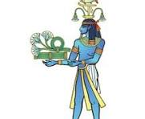
The first triad opens at the river. Plague one, blood. Moses meets Pharaoh at the Nile in the morning, lifts the staff, and the river turns to blood. Fish die. The water stinks. Egyptians cannot drink it. The text says they had to dig along the banks of the Nile just to find water that was still drinkable. Imagine the picture. A nation that built one of the great civilizations of the ancient world, scratching at the sand at the edge of their own river to find something to put in their mouths. The reason this was so devastating is that the Nile was not just a river to Egypt—it was a god, and his name was Hapi. He was the god of the Nile’s annual flooding and was depicted as a man with a swollen belly, water flowing from his hair. The Nile flooded every year, making Egypt the breadbasket of the ancient world. Hapi was thanked for it every time. Khnum was the ram-headed deity believed to guard the source of the Nile. In one stroke from the true God, both of them are exposed as having no real power. The lifeblood of Egypt becomes literal blood. The first witness to the divine court is called and silenced.
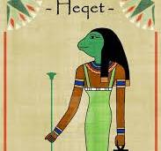
Plague two: Frogs. Frogs swarmed out of the Nile and covered the land. They crawled into beds, ovens, and kneading bowls. The Egyptian goddess of childbirth and fertility, Heqet (sometimes spelled Heket), was depicted as a frog, a frog-headed woman, or a woman with a frog's body. Because frogs appeared in massive numbers before the annual Nile flooding, they came to symbolize fertility and teeming life. Frogs were so sacred that killing one carried serious religious weight. According to historical analysis, ancient Egyptians viewed frogs as sacred, and accidentally stepping on or killing one could be punished by death, making the plague a significant spiritual crisis for them.
There is a layer of irony here that is easy to miss. Egyptian midwives invoked Heqet to help deliver babies safely. Not long ago, in the chapters just before this, an Egyptian king had ordered the murder of every Hebrew newborn boy. The Egyptians prayed to a goddess of safe birth while ordering Hebrew infants drowned in the Nile. So when God sends her sacred animals up out of that same river in numbers no one can manage, the message is precise. The cult that did not save Hebrew babies cannot save Egypt. Now the symbol of life becomes a symbol of suffocation. Egyptians cannot escape them. They cannot move without stepping on one. And when the frogs finally die, their bodies are heaped into stinking piles all across the country. The symbol of fertility becomes an emblem of decay.
Plague three: gnats, possibly lice or mosquitoes. Four Egyptian gods are associated with this plague:
- Khepri: Represented as a scarab beetle or a man with a scarab head, Khepri was the god of the rising sun and of creation, symbolizing the sun’s daily rebirth.
- Neith: One of the oldest deities, she is sometimes associated with the spider and, in certain early myths, embodies a creator figure.
- Uatchit: Identified as the "Lady of the Marshes," she is associated with the insect swarms in the papyrus swamps.
- Ahti: A rare and obscure deity, often associated with wasps and regarded as protective yet spiteful, sometimes depicted with a hippopotamus body and a wasp-like head.
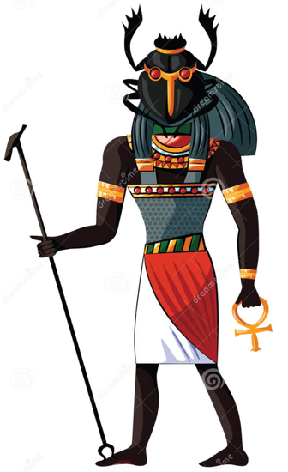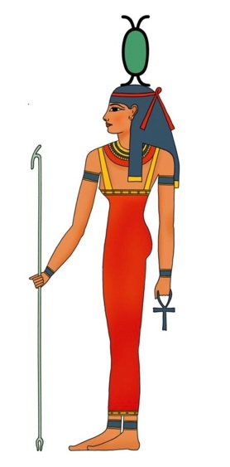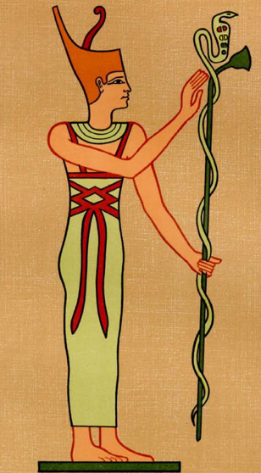
Khepri Neith Uatchit Ahti
The Hebrew word קינים (kinnim) appears only here in the entire Old Testament, and its exact meaning is debated. What is certain is that small biting insects rise from the dust of the earth and cover everything. But something new happens for the first time. Pharaoh's magicians fail to replicate it. They had imitated the staff turning into snakes, the blood, and the frogs, at least in some form. But on this one, they cannot. And they say something that lands like a thunderclap in their own court. They turn to Pharaoh and say, "This is the finger of God." Remember that phrase because it will surface later in a place no one expects.
So here is where we are. Three plagues, three blows, each calling a major Egyptian deity to account and exposing it as powerless. The river god is silenced, and the fertility goddess is exposed. The earth itself rises up against the Egyptians, while the magicians admit out loud that something divine is at work. The first triad has done its job. The god of Israel exists, and Pharaoh's experts have just admitted it.
But something even bigger is at work here. Hebrew scholars have noticed that the plagues are not merely dismantling the Egyptian pantheon. They deliberately reverse the creation account in Genesis chapter One. Water that God called good becomes blood. Creatures that God said to multiply across the land begin to swarm uncontrollably. Dust, from which God formed humanity, becomes a plague. The God who once spoke order into chaos now speaks chaos into a nation that refused to acknowledge him. He is “uncreating” Egypt, step by step, day by day, until nothing is left. This means the plagues are not arbitrary. They are a declaration written into the structure of the universe itself. This pattern shows that.
Now, the second triad commences. Here, God begins to do something he had not done in the first three plagues. He begins to separate. Plague four: Swarms. The Hebrew word here is (ערב arav), which simply means "swarm". Translators often render it as “flies” based on the Greek Septuagint translation of κυνόμυια (kunomuia, a word for dogfly), a particularly vicious, biting insect. Whatever the exact creature was, the swarms ruined the land.
And for the first time, God explicitly draws a line. Exodus 8:22 says, "I will set apart the land of Gan in which my people dwell that no swarms of flies shall be there." Gan was untouched, while the rest of Egypt was overrun. The Egyptians had insect-related deities, but they were now powerless to keep their own creatures in check. The bigger development is the line God drew. From this plague forward, Israel is shielded. The watching Egyptians can see with their own eyes that this God knows the difference between his people and the rest. The court has not just established that He exists. It is now established that He sees and He chooses.
Plague five: Livestock. A severe disease strikes the cattle, horses, donkeys, camels, and flocks of Egypt. Again, Israel's livestock are spared. Pharaoh sends men to investigate because he cannot believe it. Word comes back, "Not one Israelite animal has died." This plague hammers Hathor, the cow-headed goddess of motherhood and fertility. Apis, the bull deity, is considered a living god in animal form. Khnum, the ram-headed god. Egypt's entire livestock-based economy and the deities tied to it collapse in a single night. The land that worshiped its animals as gods now watches those animals fall dead in the fields.
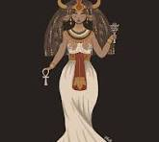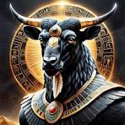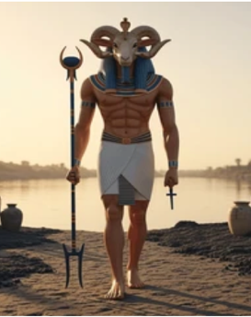
Hathor Apis Khnum
Plague six boils. Moses takes ashes from a furnace and throws them into the air. The ashes settle on people and animals, forming painful, festering boils. The text adds a detail that lands hard. Even Pharaoh's magicians could not stand before Moses because boils covered them. The very people who claimed access to Egyptian healing deities, Sekmet, Serqet, and Isis, cannot even heal their own bodies. The healers are sick, and the verdict is now overwhelming.
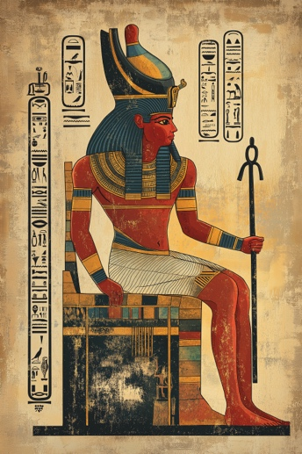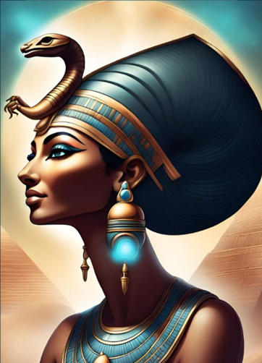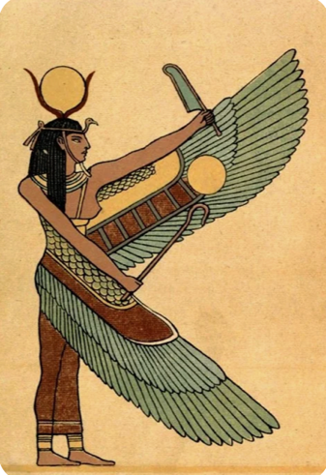
Sekhmet Serqet Isis
After plague six, the narrator quietly shifts the language. In the first five plagues, Pharaoh hardens his own heart. He sees relief between blows and digs in. But starting with plague six, the text says that God hardened Pharaoh's heart. It is as if Pharaoh has now passed a point of no return. He has had every chance to see, to repent, to relent. He has spent every chance refusing. And so, God simply accelerates the path Pharaoh has already chosen. The hardening is not the cause of his rebellion. It is the consequence of it.
There is something else worth pausing on here. The phrase God keeps using throughout this sequence, "that you may know that I am the Lord," is not aimed only at Pharaoh and the Egyptians. The very first time it appears in Exodus 6:7, God speaks it to Israel, to the slaves, to the people who had forgotten him. From the start, the plagues had two audiences. They were a courtroom for Egypt and a classroom for Israel. Every blow that exposed an Egyptian deity was also a lesson, telling a beaten-down people what kind of God they truly belonged to. The pharaoh they feared was not a god; the Nile they relied on was not a god; nor was the sun overhead. The God who had heard their groaning under the bricks was the God who held it all. By the time they walked out of Egypt, they had more than freedom; they had an answer to a question they had stopped asking generations ago: Who is your God? The plagues were how they remembered.
Plague seven. The third triad is where it all comes to a head with hail. Not just hail, but hail mixed with fire runs along the ground. The worst storm in Egyptian history. Moses warns Pharaoh in advance and tells him to bring his livestock and servants inside. And here, Exodus 9:20-21 records something easy to miss. Some of Pharaoh's officials feared the word of the Lord and brought their servants and animals home. Others did not, and their workers and livestock were left in the field to be destroyed. That is the first explicit moment in the plague narrative when the Egyptians divide among themselves. Some are starting to listen. Some are still siding with Pharaoh. The line that ran between Gan and Egypt now runs through Egypt itself. This blow targets Nut, the sky goddess; Shu, the god of the air; and Set, the god of storms.
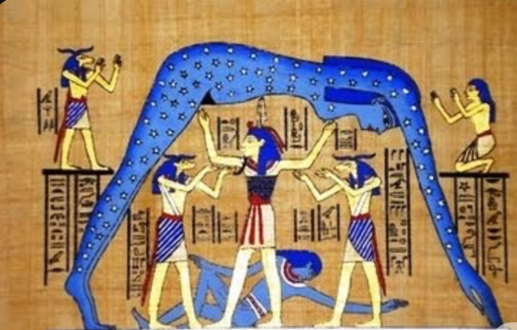 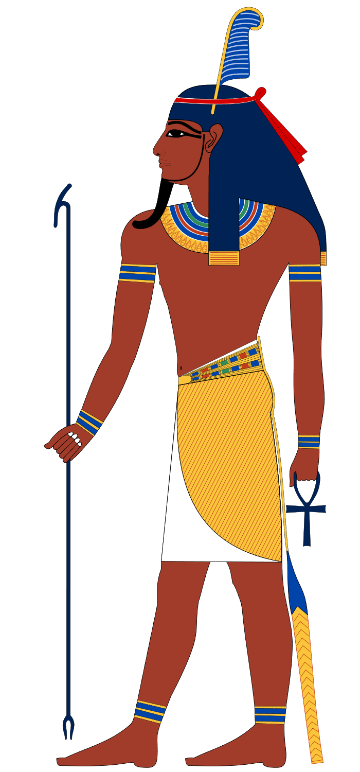 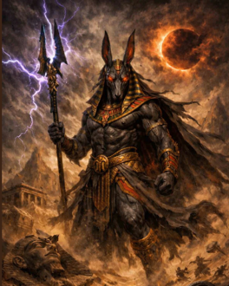 Nut Shu Set
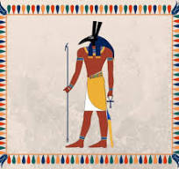
The deities meant to keep the heavens calm are now being used by the God of Israel as weapons against the very land they were said to protect. And in the midst of this storm, Pharaoh says something he has never said before. Exodus 9:27, “I have sinned this time. The Lord is righteous, and my people and I are wicked.” This sounds like repentance. The hail stops, and as soon as the pressure lifts, Pharaoh changes his mind again. The confession was real for a moment, but the repentance was not.
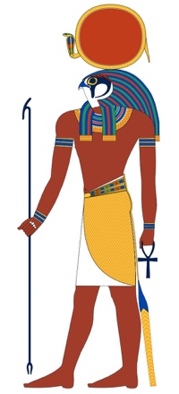
Plague eight. Locusts. Whatever survived the hail is devoured by locusts. The skies darken with them. They cover every surface. They eat every green thing. Egyptian agriculture, already broken by hail, is now annihilated. Egypt had minor deities, such as Senehem, associated with protection against pests. He was invoked for defense against ravaging pests like grasshoppers and locusts. Yet they do not protect. By this point, Pharaoh’s own officials are begging him. Exodus 10:7, “How long shall this man be a snare to us? Let the men go that they may serve the Lord their God. Do you not yet know that Egypt is destroyed?” Even his own court can see what he refuses to see.
Plague nine: Darkness. Three days of darkness so thick that the text says it could be felt. The Egyptians could not see one another, nor could they get up from their places. The Hebrew description suggests something heavier than mere absence of light. A darkness that pressed down, a darkness with weight. But in Gan, the Israelites had light in their dwellings. This blow is aimed at the apex of the entire Egyptian pantheon. Ra, the sun god, the chief deity of the kingdom. Egyptian theology held that every morning Ra was reborn and rolled across the sky on a sacred journey, and that this daily cycle was the very engine of cosmic order.
For 3 days straight, that engine stopped. Remember, Pharaoh was considered the son of Rah. So this plague does not just silence a god; it silences the god from whom Pharaoh believed he derived his authority. The man who claimed to embody the sun now sits in darkness he cannot lift. While a few miles away, the slaves he despised have lamp light on their tables. For three days, the Sun god is dethroned in his own land.
Here is the thing about this darkness, which connects right back to where the whole pattern began in Genesis One. The very first thing God does after the world is formless and void is to speak, “Let there be light.” The first creative act of God in scripture is the dispelling of darkness. In the ninth plague, God reverses that act specifically over Egypt. He withdraws the light, returning Egypt to the formless void from which the world began. The uncreation pattern is now nearly complete. The first nine plagues have fallen.
Now the structure breaks open. Plague 10 is not part of any triad. It does not follow the pattern of the others. It stands alone because it does something the other plagues were never designed to do. Plague 10: the death of the firstborn. And this time, no one is automatically protected, not even Israel. For the first time in the entire sequence, God requires something of his own people. Faith, action, a response. He instructs every Israelite household to take a lamb without blemish, slaughter it, and put its blood on the doorposts and the lintel of the house.
He says in Exodus 12:13, "When I see the blood, I will pass over you." That phrase is the origin of the word Passover. The 10th plague does what the other nine could not. It strikes Pharaoh personally—his own son dies. Pharaoh, who claimed divinity and was believed to guarantee the cosmic order through his bloodline, watches his heir die in the night. In that moment, the final defendant in the courtroom of Exodus 12:12 falls. The gods of Egypt have all been judged. The case is closed.
But notice what God required of Israel that night. He did not say, "Stay indoors and you will be fine." He did not say, "Be Israelite enough, and the angel will skip your house." He said, "Take a lamb without defect. Slaughter it. Catch the blood, put it on the doorposts, and eat the lamb dressed for travel because by morning you are leaving." After being passively spared in earlier rounds, Israel had to act. They had to participate. They had to trust the promise. And every household in Egypt that night, Israelite or Egyptian, was offered the same protection on the same terms.
Exodus 12:38 mentions a mixed multitude that left Egypt with Israel. That phrase carries weight. It means there were Egyptians or others who watched the first nine plagues unfold and, before the 10th came, decided that this god was telling the truth. They marked their doors with lamb's blood, and the angel passed over them, too. That night, the line between Israel and Egypt was not ethnic. It was the blood on the door. And then something happens that almost reads like a footnote.
As Israel leaves Egypt, the Egyptians press gold, silver, and clothing into their hands. Exodus 12:35-36 says, "The Lord gave Israel favor in the eyes of the Egyptians, and they handed over wealth so freely that the narrator describes it as Israel plundering Egypt." Centuries earlier, in Genesis 15:14, God told Abraham that his descendants would be slaves in a foreign land for generations, and afterward they would come out with great possessions. That promise was made before there was a nation of Israel, before there was a Pharaoh, before there was a Moses. And in the chaos of that final night, every word of it lands. The slaves walk out as a wealthy nation. The labor stolen from them over four centuries is, in part, returned. Even Egypt's gold is part of the verdict.
But there is one more piece. A few chapters later, Pharaoh changes his mind one last time and chases Israel to the edge of the sea. The same God who turned the river to blood now opens the sea. He walks His people through on dry ground and brings the waters back down on the Egyptian army. Several scholars have argued that the Red Sea is not separate from the plagues but rather the closing of the uncreation pattern. In Genesis 1, God separated the waters and brought forth dry land for life. At the Red Sea, He does it for Israel one last time and then lets the waters collapse on Egypt. Genesis provided order for His people. Genesis was also reversed for those who would not let them go. And when Israel finally turns and looks back, the text says they see Egyptians dead on the shore, a land emptied, a nation undone. The case is fully closed.
Remember the magicians in Plague 3? They said, "This is the finger of God." Centuries later, in Luke 11:20, Jesus picks up that exact phrase, "Casting out demons." He says, "If I cast out demons by the finger of God, surely the kingdom of God has come upon you." The same phrase, the same claim, the same divine power that toppled the gods of Egypt now stands in human form, walking through Galilee, casting out the spiritual rulers behind every false system. The plagues exposed the powerlessness of Egypt's idols. The cross exposed and defeated the spiritual powers behind every idol that ever was.
Colossians 2:15 says that on the cross, “Christ disarmed principalities and powers and made a public spectacle of them.” That language of public exposure mirrors what the plagues did to Egypt's pantheon. What was hidden behind statues and rituals was dragged into the open and shown to be empty. Egypt was the rehearsal. Calvary was the reality. Look at how the 10th plague centers on a lamb—a spotless lamb slaughtered. Its blood was applied to the doorpost. The judgment of God passes over the household covered by that blood.
Centuries later, John the Baptist sees Jesus coming and says, "Behold the lamb of God who takes away the sin of the world." Paul writes to the Corinthians, "Christ, our Passover lamb, has been sacrificed." The whole 10th plague is a shadow of the cross. The blood on the doorposts is a shadow of the blood on the cross. And just as in Egypt, the blood does not save automatically. It has to be applied. The Israelites had to take the lamb, kill it, and put the blood where it could be seen. Faith was required, not faith in the abstract, but a faith that did something. That is still the offer.
Picture a courtroom. The defendant is on trial, and the prosecutor is presenting the case in segments. Three witnesses for the first charge, three for the second, three for the third. Each witness presents evidence so clear it cannot be denied. After each witness, the judge pauses and asks the defendant whether he is ready to acknowledge what is now obvious. After each pause, the defendant refuses. He pounds the table, shouts that the witnesses are lying, and demands to see the next one, convinced he can outlast the case being built against him. By the seventh witness, even the defendant's own attorneys are leaning in and whispering, "Please just stop. Settle. You are losing this."
However, the defendant ignores them. By the time of the ninth witness, the courtroom is silent. Everyone can see what is coming. Everyone except the defendant, who still believes that if he just holds out long enough, the trial will end on its own. And then the verdict falls. That was Pharaoh. The pattern was right in front of him. Every plague was a witness. Every gap between plagues was an opportunity to acknowledge the truth and walk free. Even his own officials were begging him to see it. And he refused. Not because the evidence was unclear, but because his pride could not accept what it meant. That is what hard hearts do. They are not built in a day; they are built one refusal at a time.
So, what does this mean for anyone reading the story now? Pharaoh's pattern is not unique to Pharaoh. It is the human pattern. When confronted with a truth we do not want to face, we tell ourselves that the next interruption will be the last, that the warning we just brushed off was a coincidence, and that the conviction in our chest will pass if we just wait long enough. The longer the resistance goes on, the more the heart hardens into refusal.
By the time God begins to harden Pharaoh's heart in the second half of the plagues, he is not overriding Pharaoh's will. He is honoring it. He is letting the man become what he has chosen to be. That should not just frighten us; it should make us tender, because the same God who escalated against Pharaoh also paused between every blow. There was always space. There was always another offer. The plagues did not arrive in a single afternoon. They unfolded over weeks, possibly months, with intervals of relief in between. Each interval was a chance for Pharaoh to do what his magicians, his officials, and his own conscience were already telling him to do.
God was never trying to break Pharaoh. He was trying to reach him. And here's the small idol problem. Egypt's gods were obvious. They had names, statues, and temples. Most of us do not bow to anything that obvious. But anything we trust to do for us what only God can do operates on the same blueprint. A career, an image, a relationship, a bank account, or a pain we manage by reaching for something we cannot stop reaching for. The plagues did not just expose ancient deities. They expose the kind of thing humans do with anything we set up as a substitute for the one who actually holds the world together.
Sooner or later, the substitute falls. It is better to learn this gently than the way Pharaoh did. The blood on the doorpost still works, but it must be applied, not merely admired. The Israelites in Egypt were spared not because they thought the lamb was a nice idea, but because they killed the lamb, took the blood, and put it where the angel could see it. The cross does not save anyone who merely nods at it from a distance. It saves the household that has actually put into practice what was poured out. That is still the way in.
The 10 plagues were not random. They were a courtroom. Three triads, each teaching a different lesson about the God of Israel. Each plague called a specific Egyptian deity to the stand and exposed that deity as powerless. The whole sequence reversed Genesis 1, uncreating Egypt as a sermon for anyone watching. And the 10th plague stood alone because it was no longer about Egypt's gods. It was about a lamb, a door, a blood-covered household, a picture of what God would one day do for the entire world.
Pharaoh missed the pattern because his pride would not let him see it. The gods he served fell one by one before his eyes, and he kept hoping the next would hold. None did. The only thing ever held in that whole story was a lamb's blood on a doorpost in the middle of the night. That is still the only thing that holds. The God who confronted Egypt is the same God who confronts every false foundation we try to build. He does it not to destroy us but to free us. Every plague was a mercy, and every pause was an invitation.
And the One who once judged the gods of Egypt has now entered history, taken the place of the lamb, and made the way open for anyone willing to receive it. The blood that once kept death outside a door now keeps death outside a soul. The river that turned to blood pointed forward to a cross where blood became life. The same hand that wrote the verdict against Egypt's gods is the hand pierced for the very people who needed an exodus from their own. Pharaoh saw the pattern too late.
You and I are still inside the pause.

